
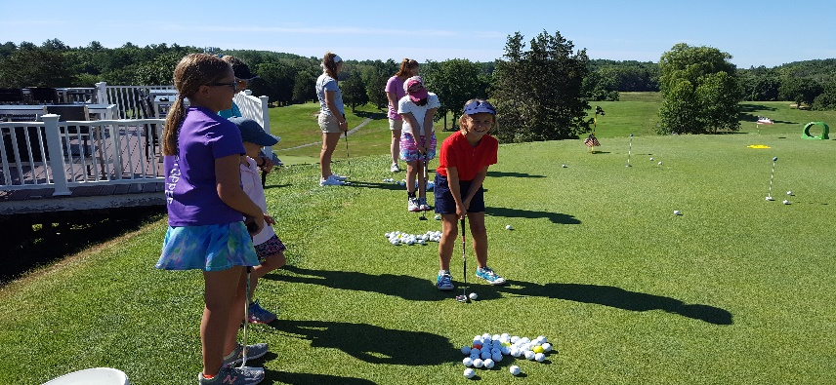
JUNIOR GOLF CAMPS
2-Day Clinics-$175:
Tuesday/Wednesday, 9:00-12:00
June 24/25 to August 19/20
ACTIVITIES:
- Swing and short game fundamentals
- Fun games/On course play
- Etiquette/Rules/Knowledge of Equipment
- Limited to 16 Juniors per Clinic, Ages 6-16
- $10 Discount for each additional Sibling
- Lunch each day-hot dogs/soda/chips/ice cream
- Golf clubs available if needed
- PGA & U.S. Kids Golf Certified Instructors
- The Importance of giving back to your Community
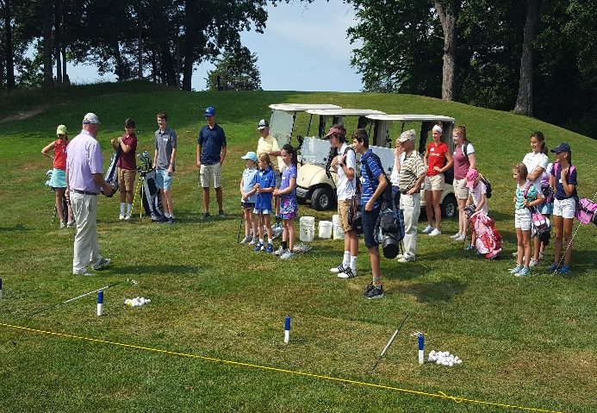
Visit or Call the Pro Shop to Enroll:
978-352-8300

