
2025 JUNIOR GOLF CLINICS
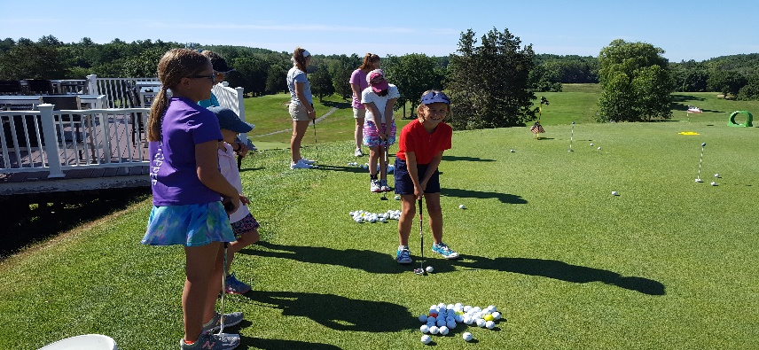
2-Day Summer Junior Clinics-$190:
Every Tuesday/Wednesday, 9:00-12:00
June 24th-25th to August 19th-20th
ACTIVITIES/INFORMATION:
- $10 Discount for each additional Sibling
- Limited to 16 Juniors per Clinic
- Each day includes hot dogs/grilled cheese/beverages/ice cream
- Team competitions and prizes/on course play
- Etiquette and Rules/Knowledge of Equipment
- Fundaments of the Swing/Fun Games
- Short Game Aspects and Skills/Course Management
- Golf clubs available if needed
- PGA & U.S. Kids Golf Certified Instructors
- The Importance of giving back to your Community
- Participation Achievement Certificate
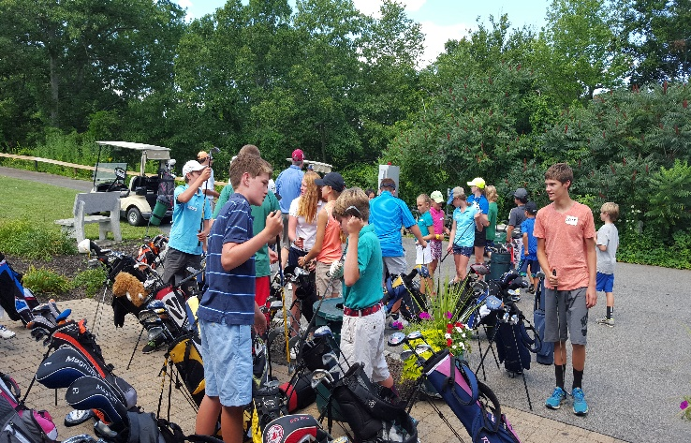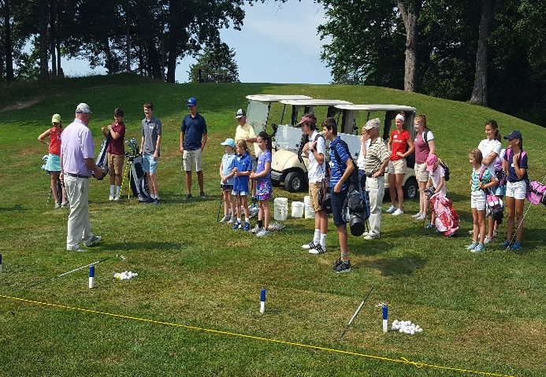
Please Visit or Call the Pro Shop to Register: 978-352-8300
For more information or questions please contact:
Chris Young, 978-270-4329, NAGolfTour@gmail.com

